EMPLOYEE ENGAGEMENT SURVEY ANALYSIS

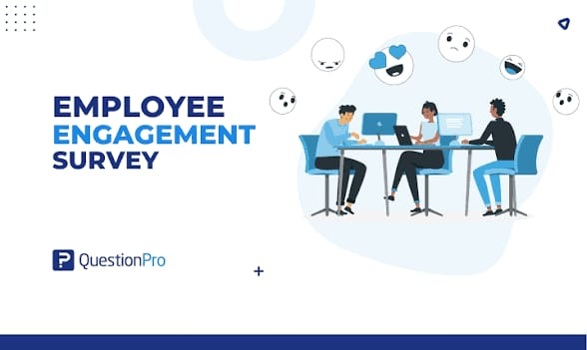

INTRODUCTION
A total of 14,725 survey responses from Pierce County employees was recorded and Data Cleaning Performed.
Before analysis, I cleaned the dataset by Standardizing Survey Questions
I found duplicate question labels:
"7. This last year, I have had opportunities at work to learn and grow"
"7. This last year, I have had opportunities at work to learn & grow"
These were merged into a single question.
The dataset contained 394 “Not Applicable” responses coded as “0”, these would artificially lower satisfaction scores, so they were excluded from the analysis.

REPORT
After Cleaning
. Total usable responses = 14,331
. Average Satisfaction Score = 3.04/4
. Positive Response = 77.3%
. Negative Response = 22.7%
This suggests that employee engagement is generally positive, but several areas require management attention.
Visualization
[Image]

Question 1
Which survey questions did respondents agree with most and disagree with most?

Highest Agreement
Rank | Question | Average Agreement Score
1 | I Know what is expected of me at work | 57.47
2 | My supervisor, or someone at work, seems to care about me as a person | 48.01
3 | At work, I have the opportunity to do what I do best every day | 40.02

INTERPRETATION
Employees clearly understand their responsibilities and expectations.
The strongest result in the survey was "I know what is expected of me at work."
This suggests management has successfully communicated job roles and responsibilities.
Employees also reported strong support from supervisors and coworkers.

Highest Disagreement
Rank | Question | Average Disagreement Score
1 | I have a best friend at work | 36.44
2 | In the last seven days, I have received recognition or praise for doing good work | 21.28
3 | My supervisor holds employees accountable for performance | 14.25

INTERPRETATION
The weakest area was workplace relationships and recognition. Employees do not consistently feel:
* Appreciated
* Recognized
* Connected socially
The low score for employee recognition is particularly concerning because recognition is a major driver of engagement and retention

Question 2
Are there patterns or trends by department or role?

DEPARTMENT ANALYSIS
Highest Satisfaction Departments includes
- Family Justice Center (3.51)
- Emergency Management (3.44)
- Executive Office & Directors (3.37)
Lowest Satisfaction Departments includes
- Sheriff's Department (2.43)
- District Court (2.97)
- Planning & Public Works (3.03)

Key Trend
There is a substantial gap between departments.
The Family Justice Center scored over 1 point higher than the Sheriff's Department.
This suggests that employee experience varies significantly depending on department leadership and workplace culture.

LEADERSHIP VS NON-LEADERSHIP ROLES
Key Trend
Employees in leadership positions consistently reported higher satisfaction than non-leadership employees.
This may indicate:
* Better access to information
* Greater autonomy
* Stronger sense of purpose
* More influence over workplace decisions
Frontline employees appear less engaged than leadership.

Question 3
What steps should the employer take to improve employee satisfaction?

1. Improve Employee Recognition
The recognition question was one of the lowest-scoring items.
Recommendations:
* Monthly recognition awards
* Peer-to-peer appreciation programs
* Public acknowledgment of achievements
* Manager training on employee appreciation

2. Strengthen Workplace Relationships
The lowest-scoring question involved having a best friend at work.
Recommendations:
* Team-building activities
* Cross-department collaboration
* Employee resource groups
* Informal networking opportunities

3. Improve Accountability Systems
Employees showed concerns regarding performance accountability.
Recommendations:
* Clear performance expectations
* Regular feedback sessions
* Transparent performance review processes

4. Focus on Low-Performing Departments
Particular attention should be given to:
* Sheriff's Department
* District Court
* Planning & Public Works
Conduct department-specific surveys or focus groups to identify root causes of dissatisfaction.

5. Expand Growth Opportunities
Although not the lowest score, opportunities to learn and grow scored lower than expected.
Recommendations:
* Mentorship programs
* Leadership development pathways
* Tuition reimbursement
* Internal promotion programs

Additional Insights
Insight 1: Employees Understand Their Jobs
The highest-scoring question concerned understanding expectations.
This means role clarity is not the organization's major challenge.

Insight 2: Recognition Is a Bigger Problem Than Compensation
Employees scored recognition lower than nearly every other factor.
This indicates that appreciation and feedback may be stronger drivers of dissatisfaction than job understanding.

Insight 3: Leadership Experiences the Organization Differently
Directors scored nearly 0.35 points higher than non-directors.
This gap suggests leaders may not fully experience the same challenges as frontline staff.

Insight 4: Overall Satisfaction Is Positive but Not Exceptional
Average Score = 3.04 / 4
While generally favorable, this score is not high enough to suggest a highly engaged workforce.
The organization appears stable but has room for significant improvement.

CONCLUSION
The survey reveals a workforce that:
- Understands its responsibilities
- Believes work is meaningful
- Generally trusts supervisors
However, employees report challenges related to:
- Recognition and praise
- Workplace relationships
- Performance accountability
- Satisfaction in certain departments
If management focuses on recognition, employee development, and targeted interventions in low-performing departments, overall engagement and satisfaction are likely to improve substantially.

